

Booking related information

Once a TIR (container) or a Dock Receipt (loose cargo) is entered against the Booking, a detailed information about their numbers can be viewed from the booking by highlighting the line item and double-clicking on it. A window like the following will open.

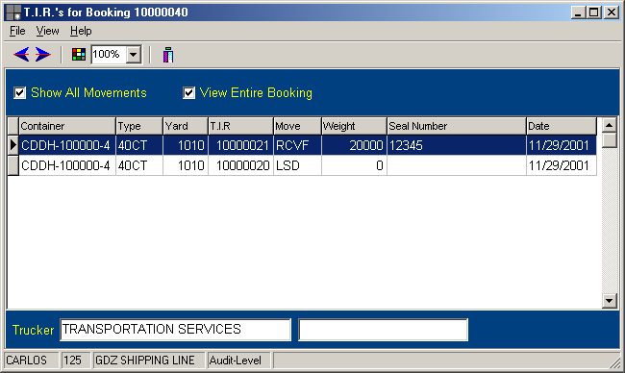

It shows specific information, such as, container number, container yard, equipment type, type of movement and date, among others. If the booking has different equipment types being reserved, the information pertaining to those line items can be viewed as well, by selecting the entire booking option.
The show all movement options, as it name says, will show all the movements attached to that container and that booking.

