

Container Yard/Warehouse

Container Yards and warehouses have the same type of setup in ISIS. This is also a company that in order to be used in ISIS has to exist in the CMS. From the document, when right-clicking on the mouse on the container yard field, a list of options will appear, Yard List among them. A window like the following will show up with all the available yards in the system. It can be ordered either by number or by name. When highlighting the desired name, hit Enter or double-click on it to assign it to the document. This list will only be available in the edit mode.

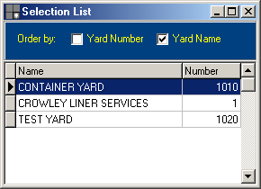

During the setup procedure of the warehouse\container yard, there is an option to define the type of numbering; this can be manual, automatic or mixed, meaning that it will accept, either manual or automatic numbers assigned by the computer. You will also be asked for the port of loading for this yard.

