

Dangerous Cargo Master

This window contains the list of all hazardous information. It will default to the descriptions that have been used for that description before, but you can always go to the Master List and search by Key Word, Proper name or UN Number. Once you find the desired one, click on the option Add to document. It will assign it to the lower screen, which you can modify and add phone numbers and names if needed. You can create a specific description in the lower screen as a new record, which would only be attached to this document. A new line item can be added to the master list or a record can be modified, as long as the user has security to do so.

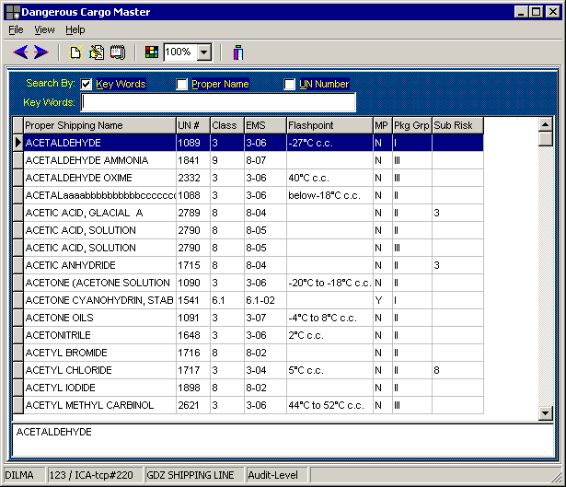

Multiple hazardous descriptions can be added to the same line item. Once you have finished close the window.
The dangerous cargo can be assigned in the Booking , dock receipt and/or in the Bills of Lading.
A hazardous material notification can be printed based on the information in the booking. It is also reflected in the manifest and loading guide.
To view the information that has been entered in a B/L or in a Booking, right –click on the corresponding line item and select the appropriate option

