

Jobs

The way ISIS identifies the voyages is through the term job. A job is a vessel/voyage combination created to represent an entire round trip voyage of a vessel. The job number created is in the format of XXXXXXXX-XX. The first three digits represent the line. For line 1, the first three digits of ALL jobs will be 001. The second two digits represent the year. For line 1, for the year 2008, all jobs will begin with 00108. The next three digits represent a sequential number given to each job as they are entered. The first job of the year 2008 would be 00108001, the next 00100802, and so on. The –XX, will either be –00, -01, or –02. –01 is for those documents created against shipments inbound to the U.S.; -02 is used for those documents outbound from the U.S.; -00 is used for accounting purposes against the vessel itself (not referring to any inbound or outbound shipments).

At the job field, the right button of the mouse may be clicked to get additional features. When doing this, an option of Job list will appear. When selected, a list of jobs that exist in the system for the ports of loading and discharge that you are working with and the sail date two weeks from the current date will appear. As you modify the date, different jobs will appear. Select the desired one and hit Enter or double click on it. It will be assigned to the document, along with the vessel name, voyage, and date.

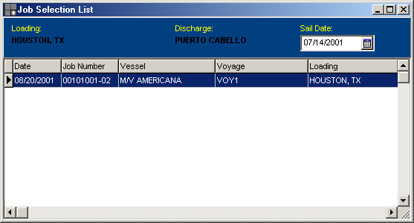

This list can only be viewed at the moment of editing the document. After it is created, it will not be active anymore

