

Ports

ISIS works with four different kinds of ports, which are used in every document from the traffic module and some from the accounting module. All the ports that are going to be used have to be created previously in the port file and the Loading/Discharge ports must be in the port schedule of the job (e.g. port of call for the voyage). They must have been assigned to the job you are working with, and also assigned in the Line/Port master, as a port of call for the line.
The port of Origin is used to indicate the name of the port or the city that the cargo is originating from. If the cargo is originating at the Port of Loading, then .N.A. should be assigned. The Loading Port is used to indicate the name of the port or city that the cargo is going to be loaded at and the Discharge Port is used to indicate the name of the port or city that the cargo is going to be discharged at. If the Port of Final Destination is the same as the Port of Discharge, .N.A. should be assigned to this field, otherwise, enter the desired port. To assign a port name in any of these fields, simply type a few letters and the system will find it for you. <PageUp> and <PageDown> keys can be used to scroll alphabetically through the names of ports or cities on file.
You can also use the mouse right-button of the mouse to display the properties of every field and you will find a Ports list option. When selecting it, a list as shown below will appear.

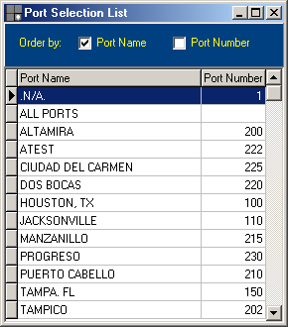

Just double click or hit Enter on the desired port in the list and it will be assigned to the respective field.
The list can be ordered by port number or port name and will only be displayed at the moment that the document (booking, dock receipt, TIR, bill of Lading) is being created, and not after it already exists.

