

Warehouse

This is also a company that in order to be used in ISIS has to exist in the CMS. From the document, when right-clicking on the mouse on the container yard field, a list of options will appear, Yard List among them. A window like the following will show up with all the available yards in the system. It can be ordered either by number or by name.

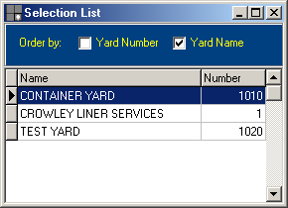

Highlight the desired one and hit Enter or double-click on it to assign it to the document. This list will only be available in the edit mode.
Not only, it has to exist in the Contact Management System, but also in the list of yards/warehouse that is defined under the Traffic Support Files. Here, you define the type of numbering that you want: manual, automatic or mixed and the port of Load.

The warehouse system in ISIS could be very general or very specific. Some customers have locations in their warehouses, and as they receive the cargo, they want to specify the exact location, so that they can run very accurate inventory reports and an Inventory by Location. Others just use a general location, called INV, which keeps all loose cargo before it gets stuffed into a container or gets delivered to the customer.

